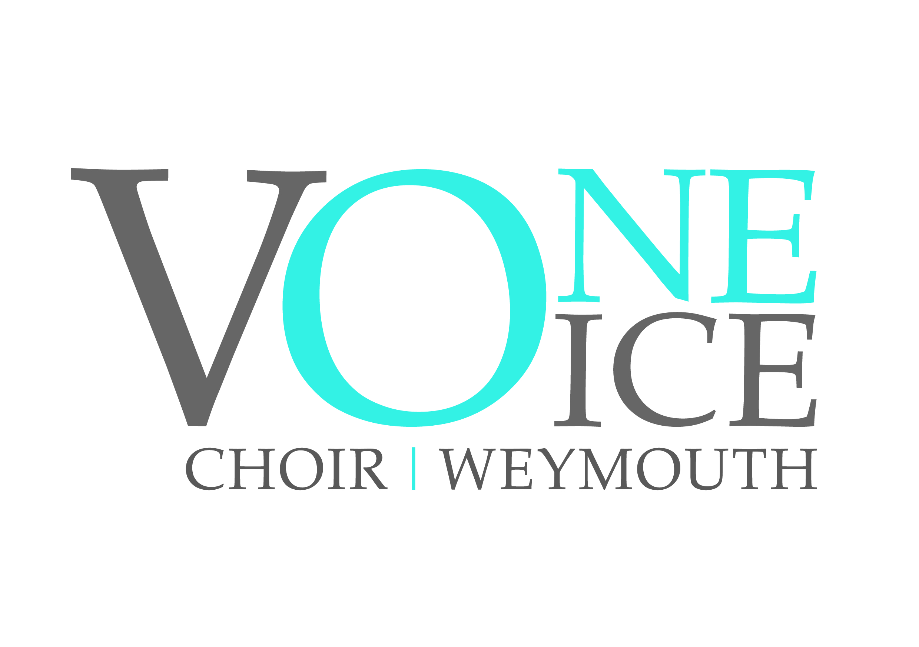Membership of One Voice Weymouth
Terms and Conditions

Registered Charity No 1179404

Name: The name of the Society shall be ‘One Voice Weymouth’ hereinafter referred to as the Society.

1. Objects

The objects of the society shall be:
- to advance, improve, develop and maintain public education in, and appreciation of, the art and science of music in all its aspects by any means the trustees see fit, including through the presentation of public concerts and recitals.

2. Membership

Membership of the society shall be open to any person interested in furthering the objects of the society, and who has paid the annual subscription at the appropriate rate or rates as shall be determined by the Committee. The subscription may be paid as:

- 1 payment annually, due in September each year
- 3 payments, due each term
- Or by standing order as 12 monthly payments

Bank details:
Barclays Bank
One Voice Weymouth (community account which is classed as a business account)
Sort Code 20 – 26 – 62
Account Number 63608476

Please provide a reference of Surname/Subs to assist us in identifying the payment.
All subscriptions being payable in advance.

Music is available for members to purchase music directly from us and is yours to
keep, we try to keep the music costs down to no more than £20 per season.
The payment for music books should be settled within 7 days of receipt of the music unless otherwise agreed with the Treasurer.
Please seek a black A4 ring binder to store your music and to use at performances.

New members have a ‘settling in’ period whereby you can decide, over your first 4 weeks if you wish to continue with the choir. During these 4 weeks you can either borrow the relevant music and return it each evening, unmarked or purchase the music. If you decide to leave after this period, the choir is not be able to reimburse the cost of any purchased music.

To be a performing member of the choir the successful completion of an audition is required. Members may be asked to re-audition every 3 years to ensure that they are singing in the right part of the choir.

Members are expected to attend rehearsals regularly.

Members should ensure that the highest possible musical standards are achieved by them, both at rehearsals, performances and concerts.

Members are expected to work at home on the songs used in rehearsals and concerts, either by listening to CD’s, on You Tube and or playing/looking at the music.

Members should advise the Chairman, Secretary or Treasurer as soon as possible, if they are unable to attend any of the rehearsals. This will help the Music Director in planning the weekly rehearsals.

Members should advise the Chairman, Secretary or Treasurer if they are NOT available to sing at a Specific concert.

Members should make every effort to attend the Annual General Meeting of One Voice Weymouth, which is normally held in January each year.

Members are expected to make every effort to sell tickets for every concert that they take part in. Payment for these tickets should be made no later than 7 days before the concert date.

Members are asked to provide refreshments for concerts and raffle prizes when requested.

The committee has the power to terminate the membership of any individual who does not comply with the terms and conditions of membership of One Voice Weymouth.

Website - members only area includes everything you might need from policies, forms, rehearsal resources, photos (not for sharing) and more!
www.onevoiceweymouth.com members button - please ask the secretary for the current password and do not share.

3. Your member data – what we need and why

We need some of your details, for example your name and email address, so that we can let you know about things like rehearsal and event dates, subscription payments, and social events.

What data do we collect from members?
We collect some of the following types of data from members (we don’t collect all of this data on all members – we only collect it if it’s needed):
- Name  - Email address  - Postal address  - Phone number  - Emergency contact details  - Photos/video footage  - Subscription payments | - Gift Aid declarations  - Bank details  - Medial information  - Age/DOB  - Gender  - Criminal records check
We check what data we have on members every two years and remove it if we no longer need it. If you leave the group, we’ll make sure we stop using and/or delete any data we don’t need to keep (e.g. for financial reporting).

What do we use it for?

Any of the information listed above might be needed to manage your membership with One Voice Weymouth and to organise and run our activities. We won’t ever use this data for anything else unless you give us your active consent for that additional use.
If you give us your consent, One Voice Weymouth will add your email to our mailing list for the group’s marketing/promotional communications. We will always include opt-out options on all such communications. You can withdraw your consent at any point by contacting the Data Protection Officer.

Do we share your data with anyone else?

- We will never give your data to third parties for that third party to use. We will sometime use third party services (e.g. Survey Monkey) to store or process your data but we will always make that they are reputable and secure, and that your data is kept safe.
- If another member of One Voice Weymouth asks for your contact details, we will only ever share them if you consent.

What can you ask us to do?

At any time, you can ask to view, update or correct any data we hold on you. You can also ask that we stop using your data or that we erase it. To request any of these, please contact the Data Protection Officer who will respond within one month.

I’ve got a question– who should I speak to?

The best person to speak to is the Data Protection Officer – Debbie Shaw.

4. Safeguarding
One Voice Weymouth believes that a child, young person or vulnerable adult should never experience abuse of any kind. We recognise that we have a responsibility to promote the welfare of all children, young people and vulnerable adults. We are committed to safeguarding the well-being of all children, young people and vulnerable adults we come into contact with and to protecting them from harm. Please ask the secretary for the full policy, any concerns should be directed to the Safeguarding Officer or Chairman.
5. Equal Opportunities
One Voice Weymouth is a music group open to all. We aim to treat our members, volunteers, staff and supporters equally regardless of their age, disability, gender reassignment, marriage or civil partnership, pregnancy or maternity, race, religion or belief, sex, sexual orientation, class and socio-economic background. Please ask the secretary for the full policy.

