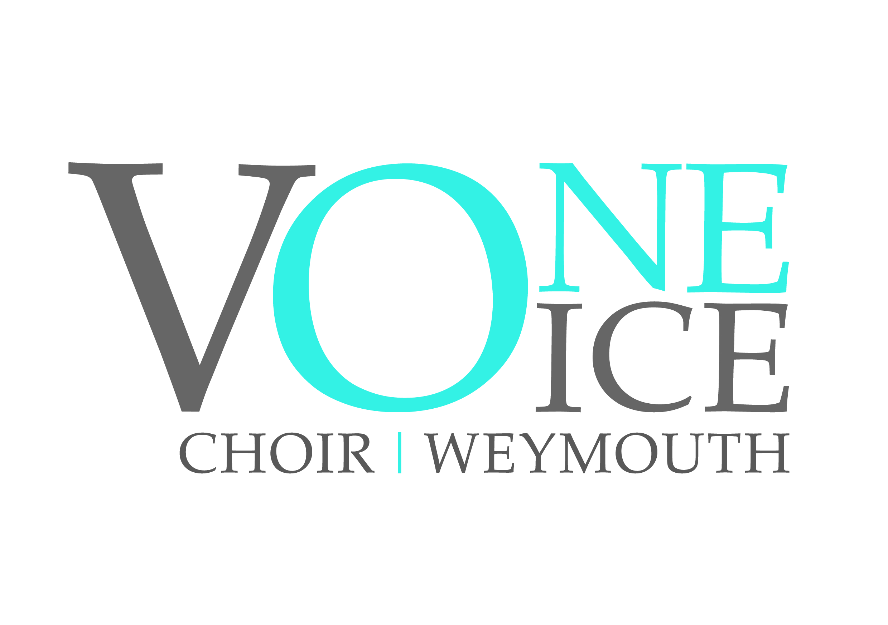

Registered Charity No 1179404

Gift Aid Declaration – multiple donation/membership subscription

‘Boost your donation/ membership subscription by 25p of Gift Aid for every £1 you donate’

Gift Aid is reclaimed by the choir from the tax you pay for the current tax year. Your address is needed to identify you as a current UK taxpayer.

In order to Gift Aid your donation/membership subscription you must tick the box below:

I want to Gift Aid my membership subscriptions and any donations I make in the future or have made in the past 4 years to One Voice Choir Weymouth.

I am a UK taxpayer and understand that if I pay less Income Tax and/or Capital Gains Tax than the amount of Gift Aid claimed on all my donations in that tax year it is my responsibility to pay any difference.

Your Details:

Title ____________________ First name or initial(s) ________________________________

Surname ___________________________________________________________________

Full Home address ___________________________________________________________________________

___________________________________________________________________________

___________________________________________________________________________

Postcode __________________________ Date ____________________________________

Please notify the Choir if you:
- want to cancel this declaration
- change your name or home address
- no longer pay sufficient tax on your income and/or capital gains

If you pay Income Tax at the higher or additional rate and want to receive the additional tax relief due to you, you must include all your Gift Aid donations on your Self-Assessment tax return or ask HM Revenue and Customs to adjust your tax code.

